Android Controlled Automobile

An Android controlled automobile project that allows user to control a battery powered automobile wirelessly through an android application. The system uses a Bluetooth modem as a medium to transmit signals between the android based phone and automobile. The android application provides a gui to the user. The commands sent through gui are sent in the form of string variables by the android application through an active Bluetooth connection. These string variables are then received by Bluetooth modem and then forwarded to the Microcontroller. The microcontroller now processes the data sent by Bluetooth modem and checks for user commands. On recognizing direction commands sent by user (Forward |Backward |Left |Right), the microcontroller sends signals to appropriate driver IC’s. The driver IC’s now operate motors to achieve the desired movement of the automobile as sent by microcontroller. This process is continuously repeated by the system to achieve appropriate vehicle movement as per user commands through the android application.

Block Diagram

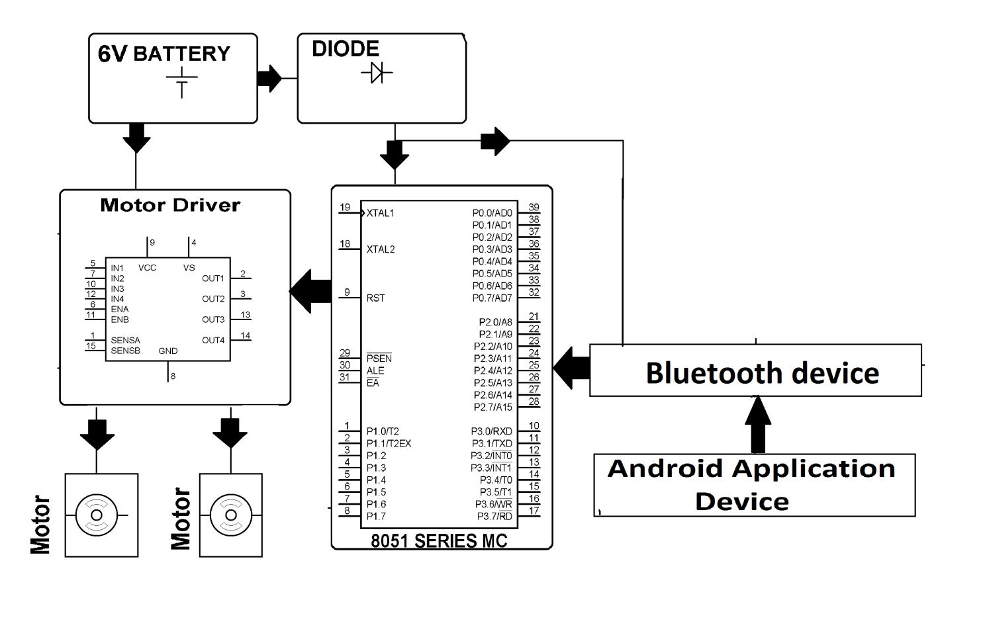

Hardware Specifications
- 8051 series Microcontroller
- DC motors
- Motor Driver IC
- Crystal
- Resistors
- Capacitors
- Voltage Regulator
- Battery
- Robot Body
- Bluetooth Device

Software Specifications
- Keil µVision IDE
- MC Programming Language: Embedded C

Bluetooth Overview

Hardware features
Typical -80dBm sensitivity
Up to +4dBm RF transmit power
Low Power 1.8V Operation ,1.8 to 3.6V I/O
PIO control
UART interface with programmable baud rate
With integrated antenna
With edge connector

- Wireless technology for short-range voice and data communication
- Low-cost and low-power
- Provides a communication platform between a wide range of “smart” devices
- Not limited to “line of sight” communication

It is preferable to use bluetooth because nowadays people have their smartphones with them all the time, since the smartphones have bluetooth facility in them, thus it's better to use bluetooth rather than using RF remotes or IR remotes. Have you ever seen people carrying remotes???
Using bluetooth has many of its own advantages :
1.It's secure.
2.Easy to use.
3.It works in short distance range(i.e. upto 10mtrs.)
4.Anyone can find free bluetooth apps on android and many more.

Reference

- http://ieeexplore.ieee.org/xpl/articleDetails.jsp?arnumber=6596385&queryText=android%20control%20vehicle&newsearch=true

